Cloud-Native DevOps Monitoring Platform

1. Cover Page

Project Title
Cloud-Native DevOps Monitoring Platform

Team Name
Devopsy

Team Members & Roles
- Akarsh Gururaju – Full Stack Development, DevOps, Cloud Deployment

Tech Stack Summary
- Frontend: React (Vite)
- Backend: Flask (Python)
- Containerization: Docker
- Reverse Proxy: Nginx
- Infrastructure: Terraform
- Cloud Platform: AWS EC2
- CI/CD: GitHub Actions

Submission Date
May 25th - 2026

2. Executive Summary
The Cloud-Native DevOps Monitoring Platform is a centralized dashboard designed to monitor cloud infrastructure, Docker containers, deployments, and application logs in real time. The platform provides live system telemetry, container tracking, deployment visibility, and automated CI/CD workflows.
The project addresses the challenge of monitoring distributed cloud systems and reducing manual deployment effort. It enables DevOps teams and administrators to quickly detect issues, monitor system health, and automate deployment pipelines.
The solution uses modern DevOps technologies including Docker, Terraform, AWS EC2, GitHub Actions, React, Flask, and Nginx.

3. Problem Statement
Modern cloud applications require continuous monitoring and automated deployment pipelines to maintain high availability and operational reliability. Many organizations struggle with:
- Lack of centralized monitoring
- Difficulty tracking Docker containers
- Manual deployment processes
- Delayed issue detection
- Complex infrastructure management
This problem affects:
- DevOps Engineers
- Cloud Administrators
- Development Teams
- Organizations hosting cloud applications
Without proper monitoring and automation, businesses may experience downtime, slower deployments, and increased operational overhead.

4. Proposed Solution
The proposed solution is a cloud-native monitoring dashboard that provides:
- Real-time infrastructure monitoring
- Docker container tracking
- Deployment monitoring
- Centralized log visualization
- Automated CI/CD deployment
The system collects system metrics such as CPU, RAM, disk usage, uptime, and Docker container details through backend APIs and displays them through a responsive web dashboard.
The platform integrates Terraform for infrastructure provisioning, Docker for containerization, Nginx for reverse proxying, and GitHub Actions for deployment automation.

Unique Value & Innovation
- Lightweight and scalable monitoring solution
- Automated deployment pipeline
- Cloud-native architecture
- Real-time dashboard updates
- Easy deployment using Docker Compose

5. Use Cases

Use Case 1 – Real-Time Infrastructure Monitoring

Actors
- DevOps Engineer
- Cloud Administrator

Preconditions
- Application is deployed on AWS EC2
- Docker services are running

Workflow Steps
- User opens dashboard
- Frontend requests monitoring APIs
- Backend collects system metrics
- Dashboard displays live metrics

Success Criteria
- CPU, memory, storage, and uptime are displayed correctly

Use Case 2 – Docker Container Monitoring

Actors
- DevOps Engineer

Preconditions
- Docker daemon is active

Workflow Steps
- Backend accesses Docker socket
- Container details are collected
- Dashboard displays container status and logs

Success Criteria
- Active containers and status are visible

Use Case 3 – Automated Deployment

Actors
- Developer
- GitHub Actions

Preconditions
- GitHub repository connected to EC2

Workflow Steps
- Developer pushes code to GitHub
- GitHub Actions workflow triggers
- Workflow connects to EC2 using SSH
- Docker containers rebuild and restart

Success Criteria
- Updated application is deployed automatically

6. Architecture & Design

High-Level Architecture
The platform consists of:
- React frontend
- Flask backend APIs
- Docker containers
- Nginx reverse proxy
- AWS EC2 infrastructure
- Terraform provisioning
- GitHub Actions CI/CD

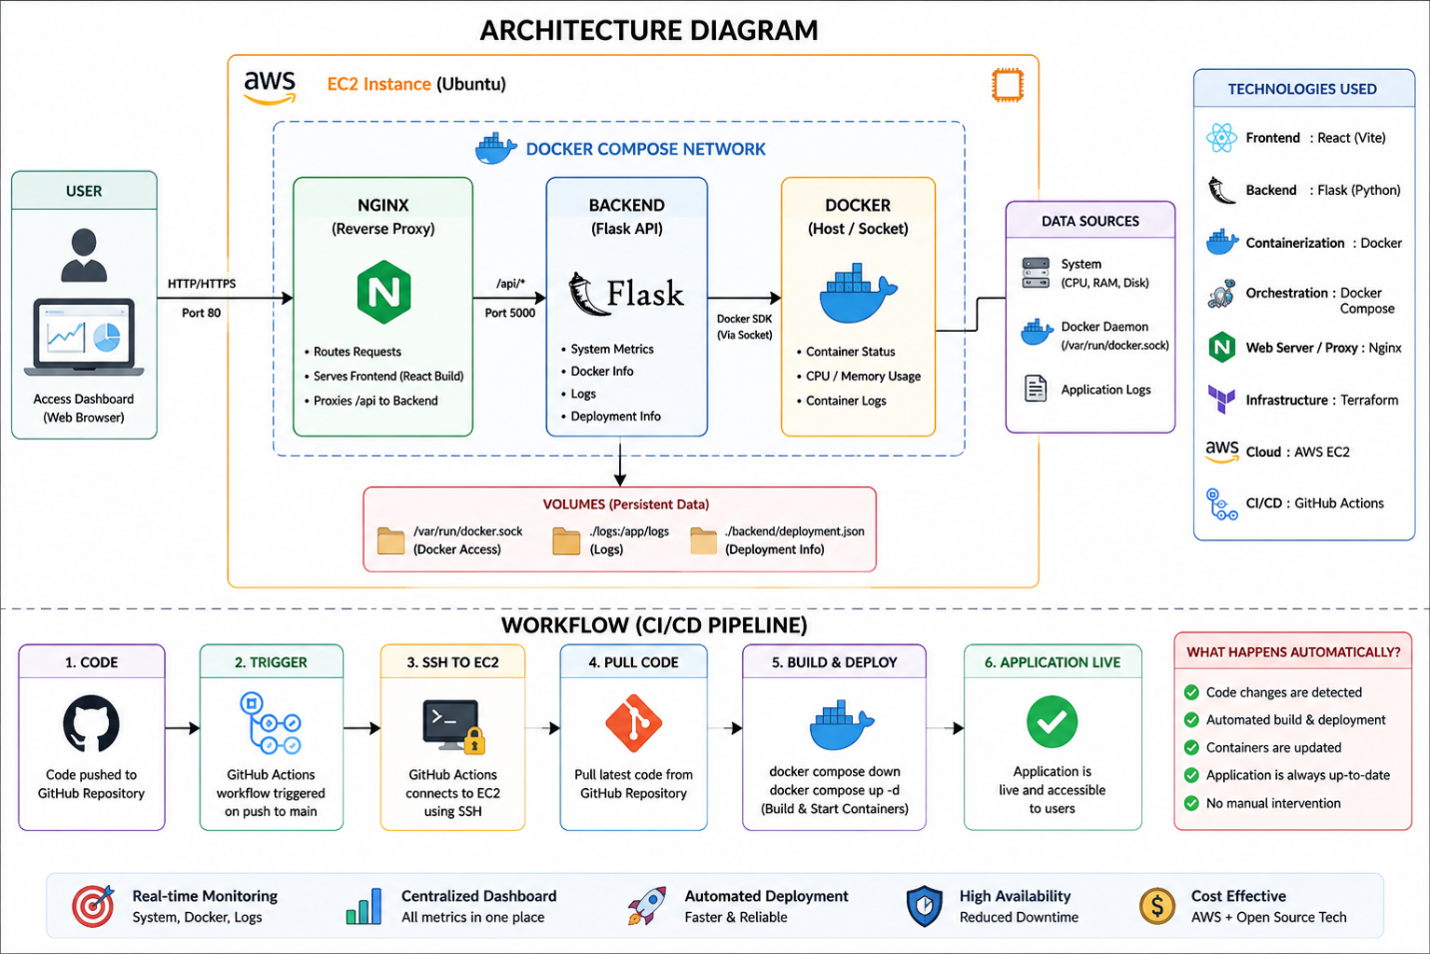

Workflow
- User accesses dashboard through browser
- Nginx routes requests
- Flask backend serves monitoring APIs
- Backend collects Docker and system metrics
- Frontend displays real-time monitoring data
- GitHub Actions automates deployments

Technology Stack Details

Frontend
- React
- Vite

Backend
- Flask
- Gunicorn

Infrastructure
- Docker
- Docker Compose
- Nginx
- Terraform

Cloud & CI/CD
- AWS EC2
- GitHub Actions

7. Features & Capabilities

Feature 1 – Real-Time Infrastructure Monitoring

Business Value
Improves operational visibility and reduces downtime.

Technical Value
Provides live CPU, memory, disk, and uptime metrics.

Feature 2 – Docker Container Monitoring

Business Value
Helps administrators track application health.

Technical Value
Displays container status, logs, and resource usage.

Feature 3 – Automated CI/CD Deployment

Business Value
Reduces manual deployment effort.

Technical Value
Automatically deploys updated code to AWS EC2.

8. Installation Guide

System Requirements
- Ubuntu 22.04
- Docker
- Docker Compose
- Python 3.10+
- Node.js 20+
- AWS Account
- Terraform

Backend Setup
cd backend
pip install -r requirements.txt
python app.py

Frontend Setup
cd frontend
npm install
npm run dev

Docker Setup
docker compose up -d

Terraform Setup
cd terraform
terraform init
terraform apply

Environment Variables
- PORT
- BACKEND_LOG_PATH
- EC2_HOST
- EC2_SSH_KEY

9. User Manual

Login Steps
No authentication required.

Input Steps
- Open dashboard URL
- Dashboard automatically loads monitoring data

Triggering Workflow
- Push code to GitHub repository
- GitHub Actions deploys application automatically

Viewing Outputs
Users can view:
- CPU usage
- RAM usage
- Storage usage
- Docker containers
- Logs
- Deployment status

Troubleshooting
- Restart Docker containers
- Check Nginx logs
- Verify backend APIs
- Check GitHub Actions logs

10. Demo Instructions

Demo Video Link
To be added.

Sample Data
Live AWS EC2 metrics and Docker container data.

Execution Steps
- Open dashboard URL
- Observe real-time metrics
- Push code to GitHub
- Observe automatic deployment

11. Innovation & Impact

Business Impact
Improves infrastructure visibility and deployment efficiency.

User Impact
Provides centralized monitoring for administrators.

Technical Innovation
Combines monitoring, cloud deployment, and CI/CD into a unified platform.

Scalability Benefits
Containerized architecture supports future scaling.

12. Technical Details

API Specifications
- /api/health
- /api/metrics
- /api/containers
- /api/logs
- /api/deployment

Data Models
JSON-based API responses.

Security
- SSH-based deployment
- Reverse proxy through Nginx
- Isolated Docker containers

Performance
- Real-time monitoring with lightweight polling
- Optimized Docker-based deployment

Scalability
- Modular microservice architecture
- Container-based deployment

13. Limitations
- No authentication system currently implemented
- Uses polling instead of WebSockets
- Limited historical log storage
- Single-server deployment
- SSL/domain configuration not added yet

14. Future Enhancements
- Add HTTPS and domain support
- Integrate Prometheus and Grafana
- Add Kubernetes deployment
- Add user authentication
- Add alert notification system
- Implement auto-scaling
- Add CloudWatch integration

15. Conclusion
The Cloud-Native DevOps Monitoring Platform successfully demonstrates modern DevOps practices including cloud deployment, containerization, infrastructure automation, monitoring, and CI/CD workflows.
The project provides a scalable and production-ready foundation for cloud infrastructure monitoring and deployment automation.

16. Appendix

API Reference
- GET /api/health
- GET /api/metrics
- GET /api/containers
- GET /api/logs
- GET /api/deployment

Additional Diagrams
- Architecture Diagram
- CI/CD Workflow Diagram

GitHub Repository
https://github.com/akarsh12A/Devops-intern-project

